OLA
Unit Listserv Instructions

OLA Units such as Library Instruction Round Table (LIRT), Outreach Round Table (ORT), etc. have elected to create listservs available through the member and event management software that is currently be used. This software vendor does not automatically sign one up for participation in a listserv even though you register to be affiliate with an OLA unit. They believe it is a personal choice that has to be made after membership is completed. So below are instructions on how to add your self to a listserv of any unit that is utilizing this option.

1. Login to your OLA membership profile using your username and password that was provided upon becoming a member or one that you have been using as a member. To login visit this website: http://olaweb.org and click on the login button.

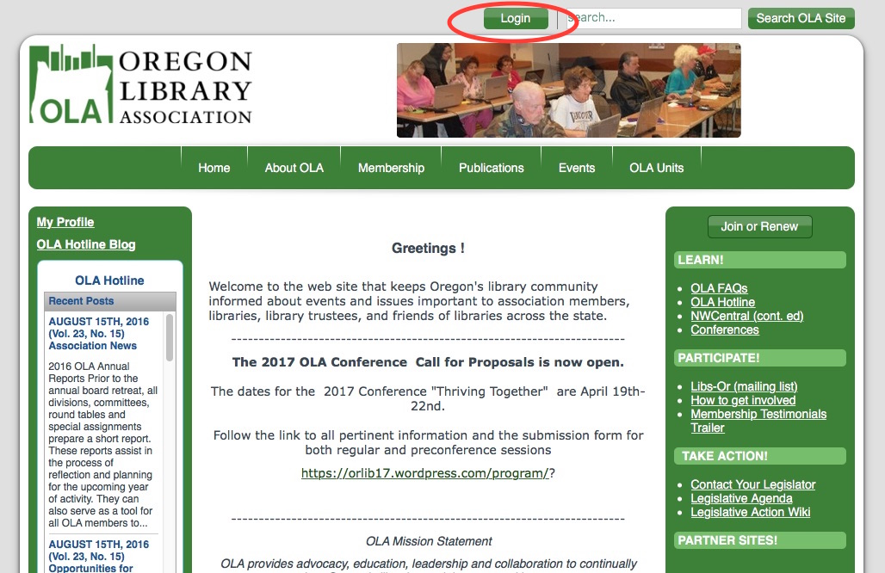

2. From the next landing page you will want to navigate to the “Home” tab in the green menu bar at the top of the page and from there select “My Porfile.”

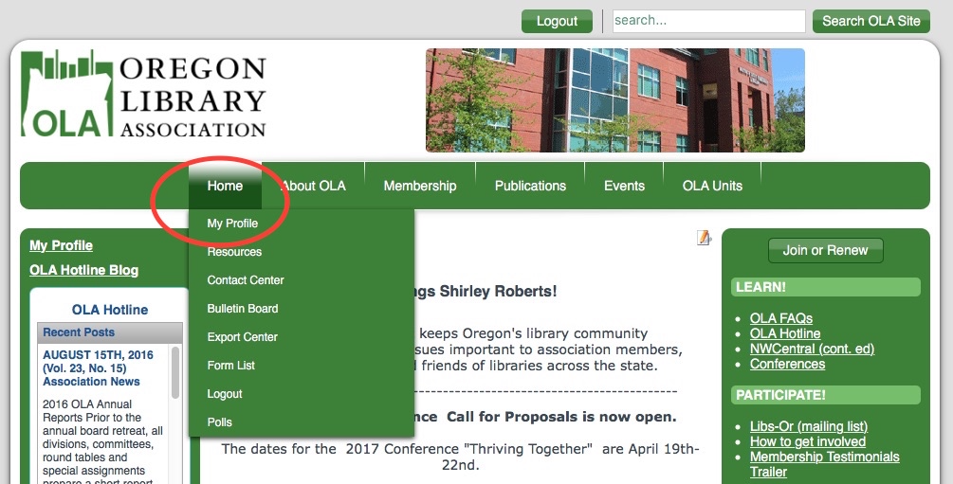

3. On the new landing page you will see profile details. Also note that there are two tabs, one labeled “My Profile” and the other “My Features.” If you click on the “My Profile” you will see where you can change your profile picture or add one if not there, change your password, etc.

Under “My Features” you find the link to “E-lists”

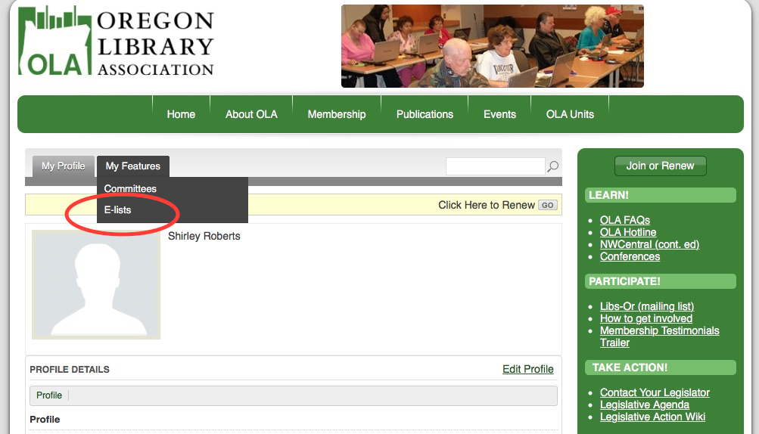
4. Clicking on the “E-lists” link, it will give you a list of the listservs that are available to you to participate in. Select those you are interested in and add the email you want the messages to go to. You should be then set to go.

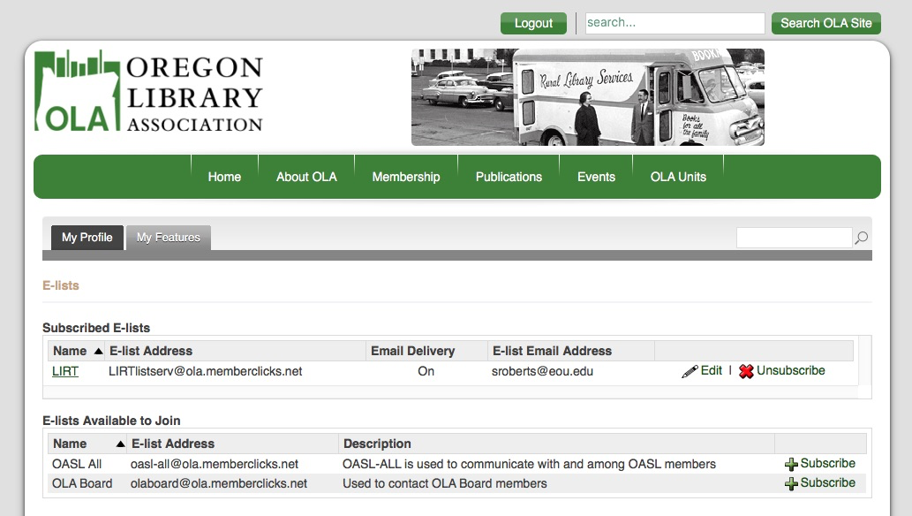

5. Tip: If you let your membership lapse and then renew, you will need to re-establish your desire to participate in the lists, so simply repeat the process above.

If you have any questions, or problems, do not hesitate to let me know.

Shirley Roberts
OLA Association Manager
sroberts.ola@gmail.com
541-962-5824

Created 2016_08_31 sjr

